**TASK-3**

**E-COMMERCE PLATFORM SEARCH FUNCTION**

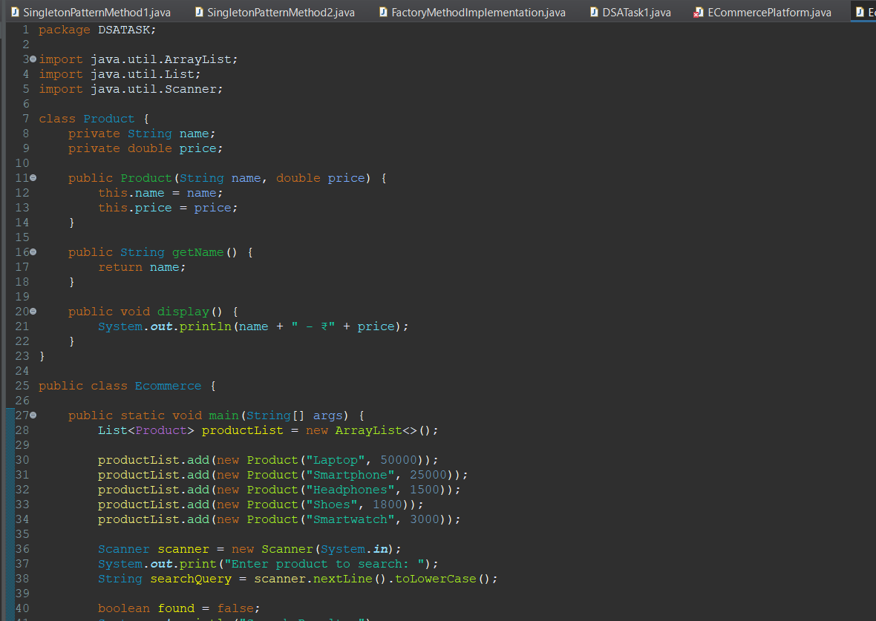

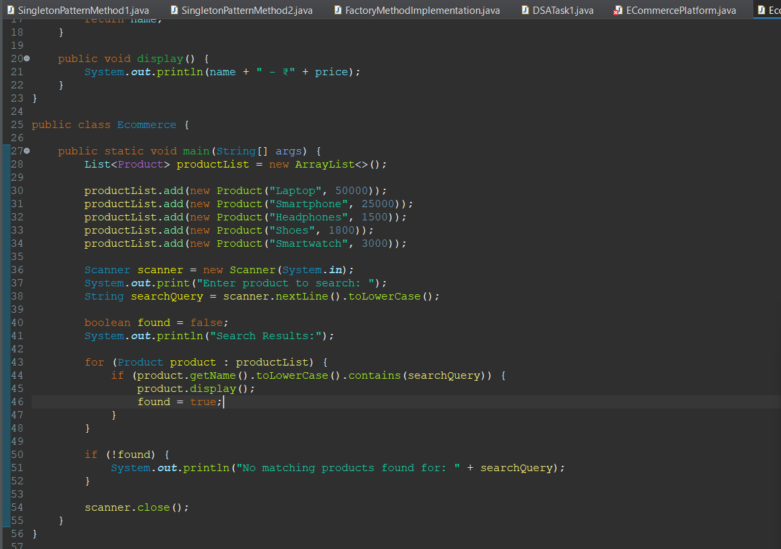

**OUTPUT**

